Software Requirements
Specification

for

SmartWear Advisor

Version 1.0 approved

Prepared by

Vansh Aggrawal(2401030211)
Keshav Mittal(2401030208)
Kumar Aryan(2401030217)
Devesh Mangal(2401030194)

20-01-2026

Table of Contents
Table of Contents
Revision of History
- Introduction 1
1.1 Purpose 1
1.2 Document Conventions 1
1.3 Intended Audience and Reading Suggestions 1
1.4 Product Scope 2
1.5 References 2
- Overall Description 2
2.1 Product Perspective 2
2.2 Product Functions 3
2.3 User Classes and Characteristics 3
2.4 Operating Environment 3
2.5 Design and Implementation Constraints 3
2.6 User Documentation 4
2.7 Assumptions and Dependencies 4
- External Interface Requirements 4
3.1 User Interfaces 4
3.2 Hardware Interfaces 4
3.3 Software Interfaces 4
3.4 Communication Interfaces 4
- System Features 5
4.1 Face and Accessory Detection 5
4.1.1 Description and Priority 5
4.1.2 Stimulus/Response Sequences 5
4.1.3 Functional Requirements 5
4.2 Weather-Based Recommendation System 5
4.2.1 Description and Priority 5
4.2.2 Stimulus/Response Sequences 5
4.2.3 Functional Requirements 6
4.2.4 Non-Functional Requirements 6
- Other Nonfunctional Requirements 6
5.1 Performance Requirements 6
5.2 Safety Requirements 6
5.3 Security Requirements 6
5.4 Software Requirements 6
5.5 Business Rules 7
5.6 Other Requirements 7
Appendix A: Glossary 7
Appendix B: Analysis Models 7
Appendix C: To be determined list 11

Revision History

Version | Date | Description of Change
1.0 | 25-01-2026 | Creation and Structure

1. Introduction

1.1 Purpose
This Software Requirements Specification (SRS) document describes the functional and non-functional requirements for SmartWear Advisor v1.0, a software system that uses face detection to identify facial accessories (such as masks and glasses) and provides accessory recommendations based on real-time weather data.
This document is intended to serve as a reference for developers, testers, project managers, and stakeholders involved in the design, development, and deployment of the system.

1.2 Document Conventions
- The word “shall” indicates a mandatory requirement.
- The word “should” indicates a recommended feature.
- Functional requirements are labeled as REQ-F-XX.
- Non-functional requirements are labeled as REQ-NF-XX.
- Priorities are categorized as High (H), Medium (M), or Low (L).
- All requirements are uniquely identifiable and testable.

1.3 Intended Audience and Reading Suggestions
This document is intended for:
- Developers – to understand system behavior and implementation constraints
- Testers – to verify functional and non-functional requirements
- Project Managers – to track scope and deliverables
- End Users – for high-level understanding of system capabilities
Recommended reading order:
- Introduction & Overall Description
- System Features
- External Interface Requirements
- Nonfunctional Requirements

1.4 Product Scope
SmartWear Advisor is an AI-based application that:
- Detects facial accessories such as masks and glasses using computer vision
- Fetches real-time weather data
- Suggests suitable accessories accordingly
Objectives:
- Improve user comfort and preparedness
- Combine AI and real-world context awareness
- Provide personalized safety recommendations

1.5 References
- OpenCV Documentation – Version 4.x
- IEEE 830 Software Requirements Specification Standard
- OpenWeatherMap API Documentation
- TensorFlow Lite Model Documentation

2. Overall Description

2.1 Product Perspective
SmartWear Advisor is a standalone application that integrates:
- Camera input
- Face detection & accessory recognition module
- Weather API service
- Recommendation engine
It may be extended in future versions to integrate with wearable devices or mobile platforms.

2.2 Product Functions
At a high level, the system shall:
- Detect a human face in real-time camera input
- Identify accessories such as masks and glasses
- Retrieve real-time weather data
- Suggest accessories
- Display recommendations to the user

2.3 User Classes and Characteristics
User Class | Characteristics
General User | Non-technical, daily use
Admin | Technical user, system configuration
Tester | Technical, validates system behavior

2.4 Operating Environment
Hardware: Webcam-enabled PC or laptop
OS: Windows 10+, Linux (Ubuntu)
Languages: Python/C++
Libraries: OpenCV, TensorFlow, Requests
Internet: Required for weather API

2.5 Design and Implementation Constraints
- Must comply with data privacy regulations
- Should have real-time performance constraint (<1 second response)
- Use of OpenCV and pre-trained ML models
- Weather data dependent on third-party API availability

2.6 User Documentation
- User Manual (PDF)
- Quick Start Guide
- In-app Help Section

2.7 Assumptions and Dependencies
- User grants camera access
- Stable internet connection
- Accuracy of third-party weather APIs
- Lighting conditions affect face detection accuracy

3. External Interface Requirements

3.1 User Interfaces
- Live camera feed window
- Detected accessory indicators
- Weather display panel
- Recommendation output text area

3.2 Hardware Interfaces
- Webcam interface via system drivers
- Optional GPU acceleration

3.3 Software Interfaces
- OpenCV for image processing
- Weather API (JSON-based REST service)
- ML model files (.h5 / .tflite)

3.4 Communications Interfaces
- HTTPS protocol for weather data retrieval
- JSON message format
- Encrypted API communication

4. System Features

4.1 Face & Accessory Detection

4.1.1 Description and Priority
The system shall detect faces and identify accessories such as masks and glasses.
Priority: High

4.1.2 Stimulus/Response Sequences
- User launches application
- Camera activates
- Face detected
- Accessories identified
- Results displayed

4.1.3 Functional Requirements
REQ-F-01: The system shall detect human faces in real time.
REQ-F-02: The system shall identify whether a user is wearing glasses.
REQ-F-03: The system shall identify whether a user is wearing a mask.
REQ-F-04: The system should handle multiple faces but prioritize the closest face.

4.2 Weather-Based Recommendation System

4.2.1 Description and Priority
Suggest accessories based on detected accessories and weather data.
Priority: Medium

4.2.2 Stimulus/Response Sequences

Face detected
- Weather data fetched
- Recommendation generated
- Recommendation displayed

4.2.3 Functional Requirements
- REQ-F-05: The system shall fetch current weather data.
- REQ-F-06: The system shall suggest masks during polluted or cold weather.
- REQ-F-07: The system shall suggest sunglasses during sunny weather.
- REQ-F-08: The system should update recommendations dynamically.

4.2.4 Non-Functional Requirements
- REQ-NF-01: The system shall have a user interface that shall be optimal.
- REQ-NF-02: The system should be able to perform optimally.

5. Other Nonfunctional Requirements

5.1 Performance Requirements
- Detection response time ≤ 1 second
- Weather API response ≤ 2 seconds

5.2 Safety Requirements
- System shall not store facial images permanently
- User must be notified before camera access

5.3 Security Requirements
- Secure API keys
- No biometric data storage
- Encrypted communication channels

5.4 Software Quality Attributes
- Usability: Minimal user interaction required
- Reliability: ≥ 95% uptime
- Maintainability: Modular code architecture
- Scalability: Support future wearable integration

5.5 Business Rules
- Only authenticated admins can modify recommendation rules
- Weather data must be refreshed every session

5.6 Other Requirements
- Internationalization support (future scope)
- Legal compliance with data privacy laws

Appendix A: Glossary
- SRS: Software Requirements Specification
- API: Application Programming Interface
- CV: Computer Vision

Appendix B: Analysis Models
- Data Flow Diagram (DFD)
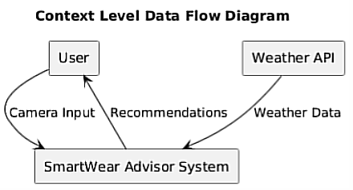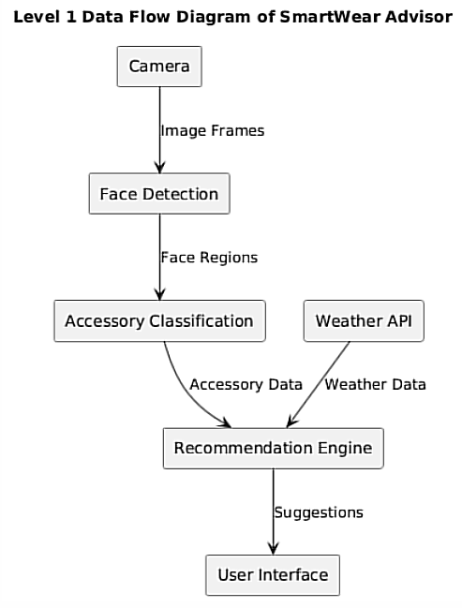
- Sequence Diagram
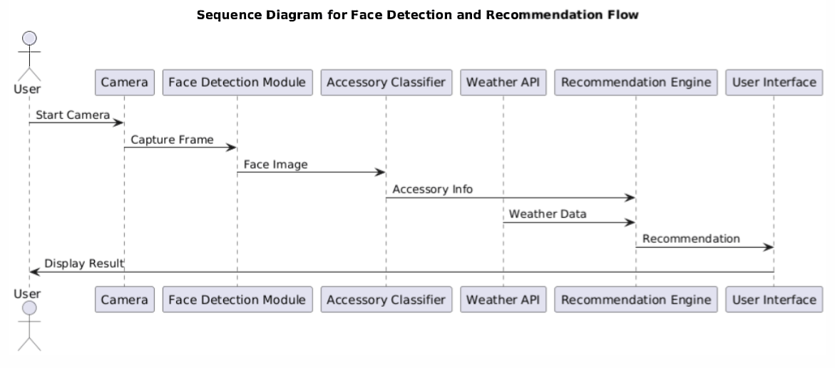
- State Transition Diagram
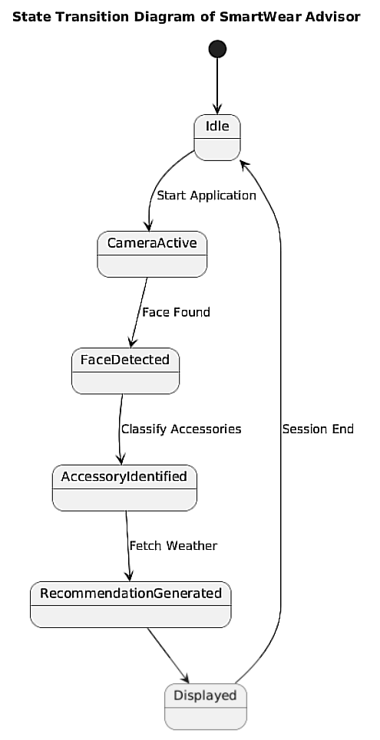

- Use Case Diagram
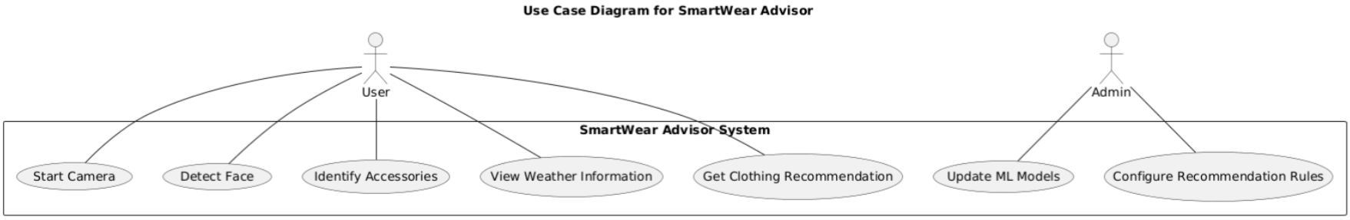

- System Architecture Diagram
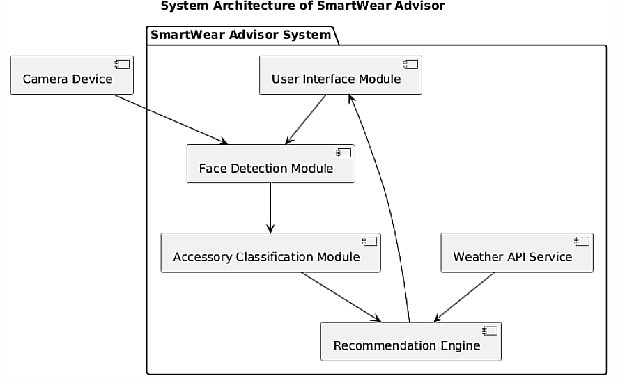
- Mathematical Models
- Face and Accessory Detection Model
F(I)={f₁,f₂,...,f_{n}}
A(f_{i})∈{Mask,Glasses,None}
- Weather-Based Recommendation Function
R=f(A,W)
Where:
- A = detected accessories
- W={temperature,humidity,condition}
Example rule:
(temp < 15∘C)∧(mask = false) => R = "Wear a mask and jacket”

Appendix C: To Be Determined
- Accuracy benchmarks for accessory detection
- Additional accessory categories
- Mobile platform support

